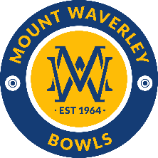
Coach - Mount Waverley Bowls.
The friendly club.

MWBC is a Division 3/4 club for Weekend pennant and Division 2/5 for Midweek pennant. The Club is one of Melbourne’s pre-eminent bowling clubs situated in the southeastern metro area. The club fields 2 Weekend and 2 Midweek Pennant sides along with Thursday, 9’s and Night pennant.

Reporting to the Committee of Management (COM), the successful applicant will be required to:
- Formulate and introduce training programs that will improve the playing performance of individual members of the Club.
- Enhance the skills of our bowlers and engender a pride in teams and achievement.
- Be a good communicator and able to engage with members of all ages and skill levels
- Work with COM and selection group on setting targets and monitor the performance of all pennant playing sides.
- Develop and assist the COM with recruitment and development of new bowlers.

Applications, expression of interest or further information, in confidence, in the first instance to Richard Sluggett at sluggettrichard@gmail.com. Please state experience, skills, and availability.

The period of this agreement is for 7 months from 1 September 2024 to 31 March 2025 for approximately 8 hours per week.

Remuneration will be discussed and negotiated during the selection process. Enquiries will be handled with the strictest of confidence.

